

***Entity Framework***

**Lab Guides**

|  |  |
| --- | --- |
| Document Code | 25e-BM/HR/HDCV/FSOFT |
| Version | 1.1 |
| Effective Date | 20/11/2012 |

**Hanoi, 07/2019**

RECORD OF CHANGES

|  |  |  |  |  |  |
| --- | --- | --- | --- | --- | --- |
| No | Effective Date | Change Description | Reason | Reviewer | Approver |
|  | 01/Oct/2018 | TuTB create new | Draft |  |  |
|  |  |  |  |  |  |
|  |  |  |  |  |  |
|  |  |  |  |  |  |
|  |  |  |  |  |  |
|  |  |  |  |  |  |
|  |  |  |  |  |  |
|  |  |  |  |  |  |
|  |  |  |  |  |  |
|  |  |  |  |  |  |

Contents

Lab: Creating Custom Exception Filter 4

Objectives: 4

Prerequisites: 4

Problem Description: 4

Guidelines: 4

Step 1: Create a class file by implementing the IExceptionFilter interface 4

Step 2: create a class file with the name LogCustomExceptionFilter.cs. 4

Step 3: Registering the Custom Exception Filter 5

Step 4: Modifying the Global.asax 6

Step 5: Modifying the Error.cshtml view 6

Step 6: Modifying the HomeController 7

|  |  |
| --- | --- |
|  | **CODE: NWEB.L.L010**  **TYPE: LONG**  **LOC: 300**  **DURATION: 60 MINUTES** |

# Lab: Creating Custom Exception Filter

Objectives:

* Learn to Creating Custom Exception Filter

Prerequisites:

* N/A.

Problem Description:

Guidelines:

### Step 1: Create a class file by implementing the IExceptionFilter interface

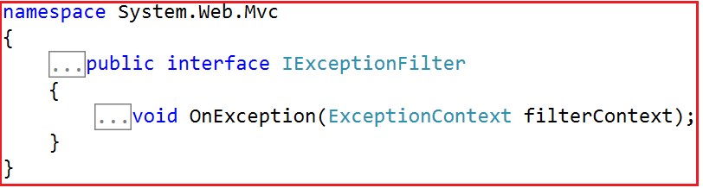

### Step 2: create a class file with the name LogCustomExceptionFilter.cs.

Create a class file with the name LogCustomExceptionFilter.cs within the Models folder and then copy and paste the following code in it

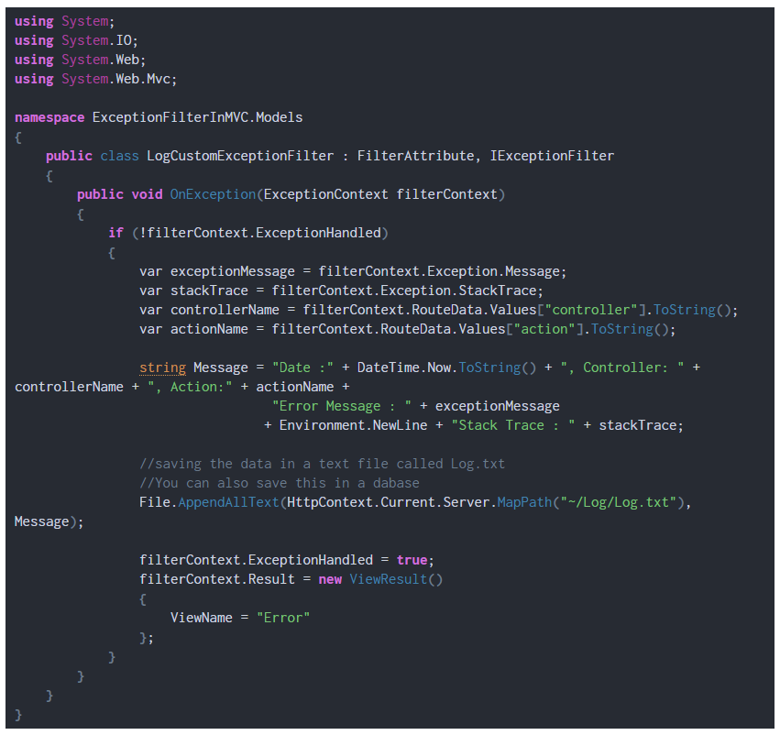

### Step 3: Registering the Custom Exception Filter

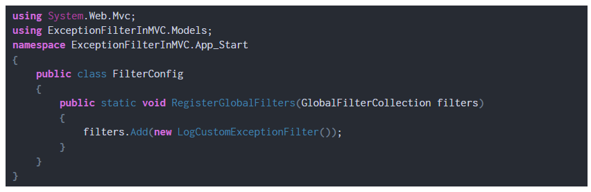

### Step 4: Modifying the Global.asax

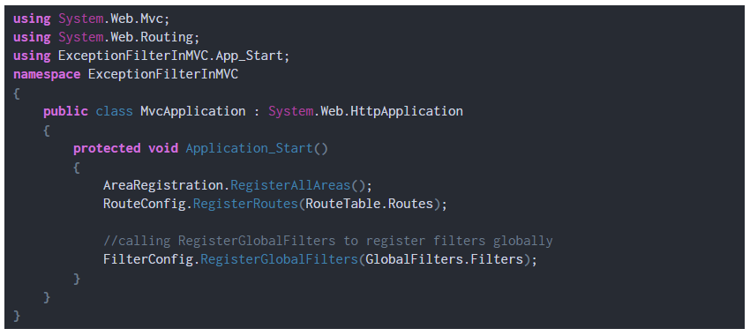

### Step 5: Modifying the Error.cshtml view

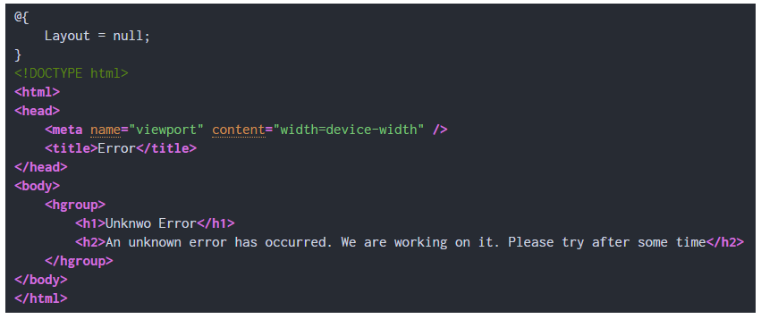

### Step 6: Modifying the HomeController

